Mid-Project
  - Deadline: Monday 09/08/2026 @ 23:59
[Total Mark is 20]

Fundamentals of Database
IT403
Instructions:
- You must submit two separate copies (one Word file and one PDF file) using the Assignment Template on Blackboard via the allocated folder. These files must not be in compressed format.
- It is your responsibility to check and make sure that you have uploaded both the correct files.
- Zero mark will be given if you try to bypass the SafeAssign (e.g. misspell words, remove spaces between words, hide characters, use different character sets, convert text into image or languages other than English or any kind of manipulation).
- Email submission will not be accepted.
- You are advised to make your work clear and well-presented. This includes filling your information on the cover page.
- You must use this template, failing which will result in zero mark.
- You MUST show all your work, and text must not be converted into an image, unless specified otherwise by the question.
- Late submission will result in ZERO mark.
- The work should be your own, copying from students or other resources will result in ZERO mark.
- Use Times New Roman font for all your answers.
Student Details: CRN:50421
Name: Hatem Hassan al-Hathloul  Name: Abdullah al-Zamil  Name: Abdullah al-Zharani  Name: Turki al-Harbi |  | ID: S220016911  ID: S230017211  ID: S230063393  ID: S230016935

Project Instructions
- You can work on this project as a group (minimum 3 and maximum 4 students). Each group member must submit the project individually with all group member names mentioned on the cover page.
- This project worth 20 marks and will be distributed as in the following:
  - Database Design. (6 marks)
  - Database Implementation. (6 marks)
  - SQL Operations. (6 marks)
  - Project Reflection. (2 marks)
- Each leader in the group must submit one report about their chosen Project via the Blackboard (Email submission will not be accepted and will be awarded ZERO marks) containing the following:
- Task 1 : database design
- Task 2: database implementation
- All requested queries/results
- Screenshots from MySQL (or any other software you use) of all the tables after population and query results.
- Reflection (300–500 words) describing the team's experience, challenges, design decisions, and AI usage (if applicable).
- Submit one SQL file containing the complete database implementation, including database creation, tables, data insertion, required queries, VIEW, and TRIGGER.
- Submit a GitHub (or GitLab) repository containing the complete project with regular commits and meaningful commit messages.
- Submit a progress report describing the completed work, key decisions, challenges, future plan, and contribution of each group member.
- Include links to the live report document, GitHub/GitLab repository, and Google Colab notebook (if applicable) in the Project Artifacts section of the final report.
- You are advised to make your work clear and well presented; marks may be reduced for poor presentation. This includes filling in your information on the cover page.
- You MUST show all your work, and text must not be converted into an image unless specified otherwise by the question.
- Late submission will result in ZERO marks being awarded.
- The work should be your own. Copying from students or other resources, including AI software, will result in ZERO marks.

Project Description
Design and Implementation of a Smart Clinic Database System
Learning Outcome(s):

CLO1, CLO2, CLO3, CLO4, CLO5

A private clinic currently manages its patient information manually, making it difficult to organize appointments, treatments, and payments. The clinic has decided to develop a database system to improve data organization and retrieval.
Your team is required to design, implement, and test a complete relational database using the concepts learned throughout this course. The project should demonstrate your understanding of database design, ER/EER modeling, relational mapping, SQL implementation, and advanced SQL queries. The project must be completed using MySQL.
Answer
Mid-Project Progress Report
- Work completed this period: We successfully formed our team, defined the 7 main entities for the smart clinic system (Person, Doctor, Patient, Appointment, Treatment, Medicine, Payment), and identified their primary/foreign keys, and completed the EER diagram design including specialization.
- Key decision made: We decide to use EER specialization approach by creating general PERSON superclass that branches into DOCTOR and PATIENT subclasses. It can reduce data redundancy for shared attribute like name and phone.
- Problem encountered: we were confused about how to link treatments and medicines. And we resolve it by identifying it as Many-to-Many (M:N) relationship which we will later implement using bridge/junction table in SQL.
- Plan to do next: our next step is to translate our EER diagram into MYSQL code (DDL) to create table, apply the necessary constraints, and insert the mock data.
- Group member input:
Project coordinator, writing assumptions and mid-progress report (Hatem al-Hathloul)
Defining entities, attributes, and primary/foreign keys (Turki al-Harbi)
Modeling relationships, cardinalities, and EER specialization (Abdullah al-Zharani)
Designing and drawing the EER diagram (Abdullah al-Zamil)

Task 1 – Database Design (6 Marks)
- Design a complete database for the clinic that includes at least six entities such as Patients, Doctors, Appointments, Treatments, Medicines, Payments, or any other appropriate entities.
- A complete ER/EER diagram.
- Primary and foreign keys.
- Appropriate relationships with cardinality.
- At least one specialization/generalization (EER feature).
- Any assumptions made during the design process.
- Entities, Attributes, and Keys
1.PERSON (Superclass)
Attributes: Person_ID (PK), Fname, Lname, Phone.
2.DOCTOR (Subclass of PERSON)
Attributes: Person_ID (PK, FK), Specialization, Room_Number.
Note: Person_ID references PERSON.
3. PATIENT (Subclass of PERSON)
Attributes: Person_ID (PK, FK), Blood_Type, Emergency_Contact.
Note: Person_ID references PERSON
4. APPOINTMENT
Attributes: Appointment_ID (PK), App_Date, App_Time, Status, DOCTOR_ID (FK), Patient_ID (FK).
Note: Doctor_ID references DOCTOR(Person_ID), Patient_ID references PATIENT(Person_ID).
5. TREATMENT
Attributes: Treatment_ID (PK), Description, Cost, Appointment_ID (FK).
Note: Appointment_ID references APPOINTMENT.
6. MEDICINE
Attributes: Medicine_ID (PK), Med_Name, Dosage.
7. PRESCRIPTION (Bridge table for M:N)
Attributes: Prescription_ID (PK), Treatment_ID (FK), Medicine_ID (FK).
Note: Treatment_ID references TREATMENT, Medicine_ID references MEDICINE.
8. PAYMENT
Attributes: Payment_ID (PK), Amount, Pay_Method, Pay_Date, Appointment_ID (FK).
Note: Appointment_ID references APPOINTMENT.

B. Relationships, Cardinality, and Specialization
EER specialization/generalization: for the EER design, we opted to build a primary superclass named PERSON, which then splits into two distinct subclasses. DOCTOR and PATIENT. We set this specialization with a Total and Disjoint (d) constraint, ensuring that any given entity is strictly be either a Doctor or a patient-never both simultaneously.
Relationship and cardinality:
Patient and appointment (1:N): we set the relationship between patient and appointment as 1:N this reflects that an individual patient is free to book multiple appointments over time, whereas any single appointment records belong strictly to one patient.
Doctor and appointment (1:N): the doctor or appointment link is structured as 1:N.
In practice, a single doctor takes on numerous appointments, but each specific appointment entry is assigned to just one doctor.
Appointment and treatment (1:N): we modeled appointment and treatment with a 1:N relationship. A single appointment session can easily involve several different treatments, but each treatment log remains tied to that specific appointment.
Appointment and payment (1:1): the mapping between appointment and payment kept as 1:1 each scheduled appointment triggers one distinct payment transaction maps back to a single appointment.
Treatment and medicine (M:N): Lastly, the relationship between treatment and medicine is defined as M:N a given treatment plan often calls for multiple medications, while a single type of medicine can naturally be used across various treatments.
C. EER Diagram
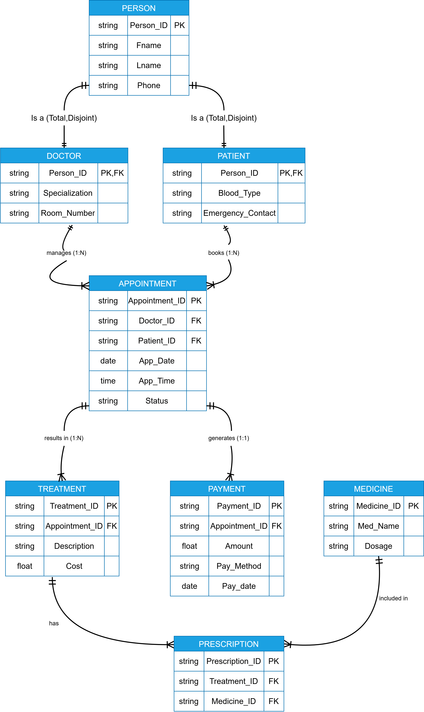

D. Assumptions
During the design of database for smart clinic, the following assumptions were made
- Total and Disjoint Specializations: A person in the clinic system must be exclusively either a Doctor or a patient and every person recorded must belong to one of these two roles (Total Completeness).
- Payment participation (1:1): Every scheduled appointment generates exactly one payment record (Total/Mandatory participation). In the case of a "Cancelled" appointment, a payment record is still generated but may reflect a zero amount ($0) or a cancellation penalty fee. This ensures full data tracking for all appointments.
- M:N Relationship implementation: To manage the Many-to-Many relationship between treatment and medicine, we implemented a Prescription bridge table and this allows a single treatment to involve multiple medicine, and a specific medicine to be prescribed across various treatment.
- EER Notation Standard: We utilized the crow’s foot notation to design our EER diagram, as it is the industry standard for relational databases. Since crow’s foot does not use explicit geometric symbols (like a circle with d) for specialization the Total and Disjoint (d) constraint has been logically enforced in our schema design and explicitly stated in these assumptions.
E. Project Artifacts
As per the project requirements, below are the direct links to our live collaborative workspace and the version control repository. Both links have been set to Public Anyone with the link can view" to ensure seamless access for evaluation.
- Live Report Document (Collaborative Workspace): [SEU-Group-Project].
Note: Viewing this document via Word Online might cause slight pagination shifts, displacing the EER diagram or tables across pages. Please refer to the submitted PDF attachment for the exact and intended layout).
- GitHub Repository: [SEU-GitHub]

Task 2 – Database Implementation (6 Marks)
Complete the following tasks using MySQL. Include screenshots of both your SQL code and the corresponding output (results) for each task:
- Create the database and all required tables.
- Use appropriate data types and constraints (PRIMARY KEY, FOREIGN KEY, NOT NULL, UNIQUE, etc.).
- Insert at least 5 records into each main table.

Task 3 – SQL Operations (6 Marks)
Complete the following tasks using MySQL. For each task, include screenshots of both your SQL code and the corresponding output (results), along with a brief description (one to two sentences) explaining the purpose of the query and the information it is intended to retrieve.
- Write SELECT statements.
- Write JOIN queries.
- Write nested queries.
- Use aggregate functions with GROUP BY.
- Write UPDATE and DELETE statements.
- Create one VIEW.
- Create one TRIGGER.

Task 4 – Reflection (2 Marks)
Write a 300–500-word reflection on your experience while completing this project by
answering the following questions. Your responses should be clear, concise, and
supported with specific examples from your own work.
- Describe one specific challenge or obstacle you encountered during this project and explain in detail how you identified and resolved it.
- Explain why you chose your specific approach/method/model over at least one alternative you considered, and what tradeoffs informed that decision.
- If you used any AI tools during this project (e.g., ChatGPT, Claude, Copilot), disclose which tool(s), for what specific purpose (e.g., debugging, grammar checking, brainstorming), and how you verified or modified the output.
- What would you do differently if you were to redo this project with more time or resources?

Deliverables
- Project Report (PDF) – System description, ER/EER diagram, relational schema, SQL code, screenshots, and reflection.
- SQL Script (.sql) – Complete SQL implementation of the project.
- GitHub Repository – Repository link with the complete project and commit history.
- Mid-Project Progress Report – Summary of progress, challenges, decisions, and team contributions.
- Project Artifacts
  - Live report document (with edit history): [link]
  - GitHub/GitLab repository (with commit history): [link]
  - Google Colab notebook (if applicable): [link]

